1. Risk Structure of Interest Rates

Financial assets of same maturities can have different interest rates due to their different risk exposures. This risk-driven interest rate difference is called the risk structure of interest rates.

For assets like bonds, one of the most common risk is default risk, which is the likelihood that bond issuers will not be able or willing to pay off their debt at maturity. This means issuers with higher default risk must pay more interest to attract investors to buy their bonds. The interest rate difference between bonds with default risk and risk-free bonds such as treasury bonds is defined as risk premium. In general, defaultable bonds have positive risk premium and it will increase with default risk. The idea of risk premium can also be explained by the loanable funds theory. Interest rates for corporate and government bonds of the same maturity should be the same if they have the same level of risk. When their risk difference is considered, part of the loanable funds supply for risky corporate bonds will transfer to the riskless government bonds due to investors’ lower risk tolerance. Therefore, the equilibrium interest rate of corporate bonds will be higher than government bonds.

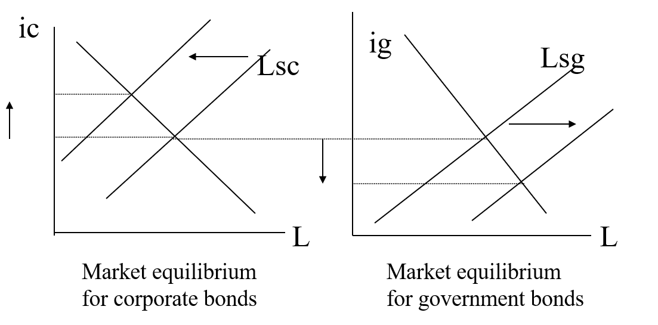

The level of risk premium changes inversely proportional to business cycles. When the economy is booming, the investors’ risk appetite will increase, and the likelihood of default will decrease. Both forces will hinder the transfer of loanable funds from corporate bonds to government bonds so risk premium will drop. Similarly, in a recession, investors are generally more conservative, and risk of default will soar. The aggregate result is a higher risk premium.

1. Term Structure of Interest Rates

The relationship between maturity and interest rate for bonds of the same risk structure is known as the term structure of interest rates. The graph plotting maturities and interest rates together is called the yield curve. There are three typical shapes: positively sloped, inverted and flat. Theories explaining the specific shape of yield curves include pure expectations theory, market segmentation theory, liquidity premium theory and preferred habitat theory.

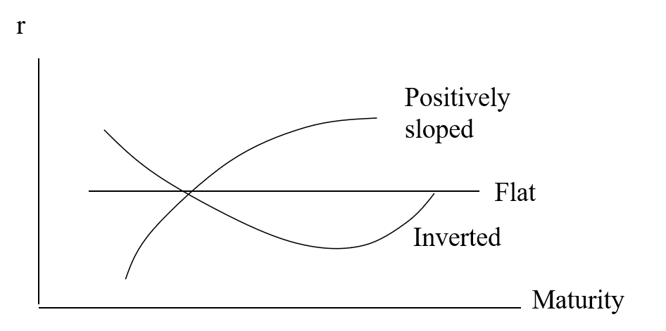

1. Pure Expectations Theory

The pure expectations theory assumes individuals have no preference over different maturities. These bonds are perfect substitutes to each other, and individuals only try to maximize expected returns in the efficient market. It concludes that interest rate of longer-dated bond is equal to the average of expected future short-term rates.

To illustrate this idea, consider two investment strategies: invest in a two-year zero-coupon bond with face value $100; invest in a one-year zero-coupon bond, collect all the proceeds, and reinvest in a one-year zero-coupon bond one year later to have $100 at maturity. Denote the spot rate at time i for bonds maturing at time j as rij. The return of the first strategy is (1+ r02)2 and the return for the second strategy is (1+r01)(1+r12). These two returns should be the same to preclude arbitrage. Ignoring higher order terms, we will get $r_{02}=\frac{r_{01}+r_{12}}{2}$. This equation shows that if the expected future rate r12 is higher than r01, r02 will be higher than r01 so the yield curve has a positive slope. The theory could be extended to n periods where we have $r_{0n}=\frac{r_{01}+r_{12}+...+r_{n-1,n}}{n}$.

A major disadvantage of pure expectations theory is that it contradicts an empirical fact: the yield curve is almost always positively sloped. According to the theory, when the slope of yield curve is positive, expected future short-term rates are higher than spot rates, which clearly does not always hold.

1. Liquidity Premium Theory

To fix the strong assumption that individuals do not have preference over different maturities and its corresponding theoretical disadvantage, John Hicks proposed the liquidity premium theory in his 1939 book *Value and Capital*. He argued that bonds of different maturities can be substitutes to each other, but individuals indeed prefer more liquid short-term bonds. Therefore, long-term interest rate should be the sum of average expected future short-term rates plus a liquidity premium. That is, $r_{0n}=\frac{r_{01}+r_{12}+...+r_{n-1,n}}{n}+{lp}_{0n}$. In general, liquidity premium increases with maturity but is ultimately determined by demand and supply.

Within this framework, the shape of yield curve does not necessarily reflect public’s expectation of future short-term rates. Specifically, the yield curve could be positively sloped even if expected future rates are the same as spot rates. In addition, expected future rates could decline even if the yield curve is flat.

1. Market Segmentation Theory

Culbertson (1957) claimed that individuals have special preferences over bonds of different maturities so that these bonds cannot substitute each other at all. This leads to the market segmentation theory where interest rates of different maturities are independently determined by their own demand and supply.

Imagine the scenario when an individual has a payment due in 5 years. If he is extremely risk adverse, he would be unwilling to buy a 10-year bond, which requires selling in 5 years, or a one-year bond that involves rolling the bond position each year and creates risk exposure for uncertain future interest rates. Then the only smart choice would be a 5-year bond. In this regard, the market segmentation theory would be applicable when interest rates are highly volatile, and individuals do not want to take extra risk to make financial plans.

There is also reasonable explanation for the generally upward sloping yield curve. In the short-term bond market, there is higher demand and lower supply due to liquidity preference. Therefore, even if bond issuers provide very low interest rates, the market would still reach equilibrium. This is not the case for long-term bond market, where issuers must provide high interest rates to attract investors when demand is generally lower and supply is higher.

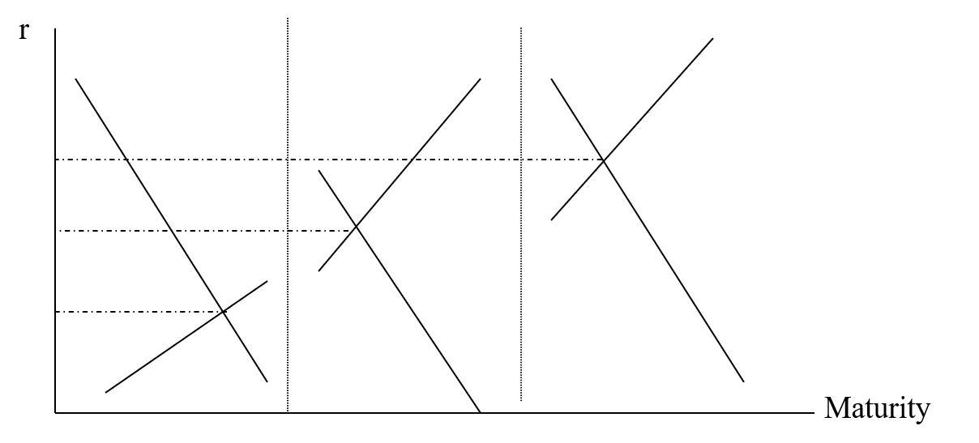

1. Preferred Habitat Theory

The most widely recognized attempt to combine all the theories above is the preferred habitat theory by Modigliani and Sutch (1966). They defined the concept preferred habitat as individuals’ preference for bonds of certain maturities. However, this preference could be deviated if there is high enough yield on bonds of other maturities.

In the two-year investment scenario, if the preferred habitat is two-year bond, for the individual to choose the rolling one-year investment, the difference between the return from the rolling investment and that of the two-year investment should be above a threshold. That is, we need $\left(1+r_{01}\right)\left(1+r_{12}\right)-{\left(1+r_{02}\right)}^{2}≥∆R$, where $∆R$ is the proxy of individual’s maturity preference. Therefore, the equilibrium rate observable in the market is $r_{02}=\frac{r_{01}+r_{12}+ΔR}{2}$.

The preferred habitat theory is very similar to the liquidity premium theory in that they have similar conclusion about long-term rates. The major difference is that the latter only considers individuals’ liquidity preference while preferred habitat theory is more general and has an indirect approach in deriving long-term rates.